Experiment: 1

**Student Name:** Sahil Kaundal **UID:** 21BCS8197

**Branch:** BE CSE (Lateral Entry) **Section/Group:** 616/A

**Semester:** 5th **Date of Performance:** 05/09/2022

**Subject Name:** DAA Lab **Subject Code:** 21-CSP-312

# Aim/Overview of the practical:

Code and analyze to compute the greatest common divisor (GCD) of two numbers

# Task to be done/ Which logistics used:

To find GCD of two numbers.

1. **Algorithm/Flowchart:**

***Step 1:*** Let a, b be the two numbers.

***Step 2:*** a mod b = R.

***Step 3:*** Let a = b and b = R.

***Step 4:*** Repeat Steps 2 and 3 until a mod b is greater than 0.

***Step 5:*** GCD = b.

***Step 6:*** Finish.

# Steps for experiment/practical/Code:

#include<bits/stdc++.h>

using namespace std;

int gcd(int x,int y)

{

if(y==0)

return x;

else

return gcd(y,x%y);

}

int main()

{

int a,b;

cout<<"Enter First Number: ";

cin>>a;

cout<<"Enter Second Number: ";

cin>>b;

cout<<"GCD of "<<a<<" and "<<b<<" is: "<<gcd(a,b);

return 0;

}

# Observations/Discussions/ Complexity Analysis:

Time complexity of finding GCD of two number using Euclidean method is O(log n).

# Result/Output/Writing Summary:

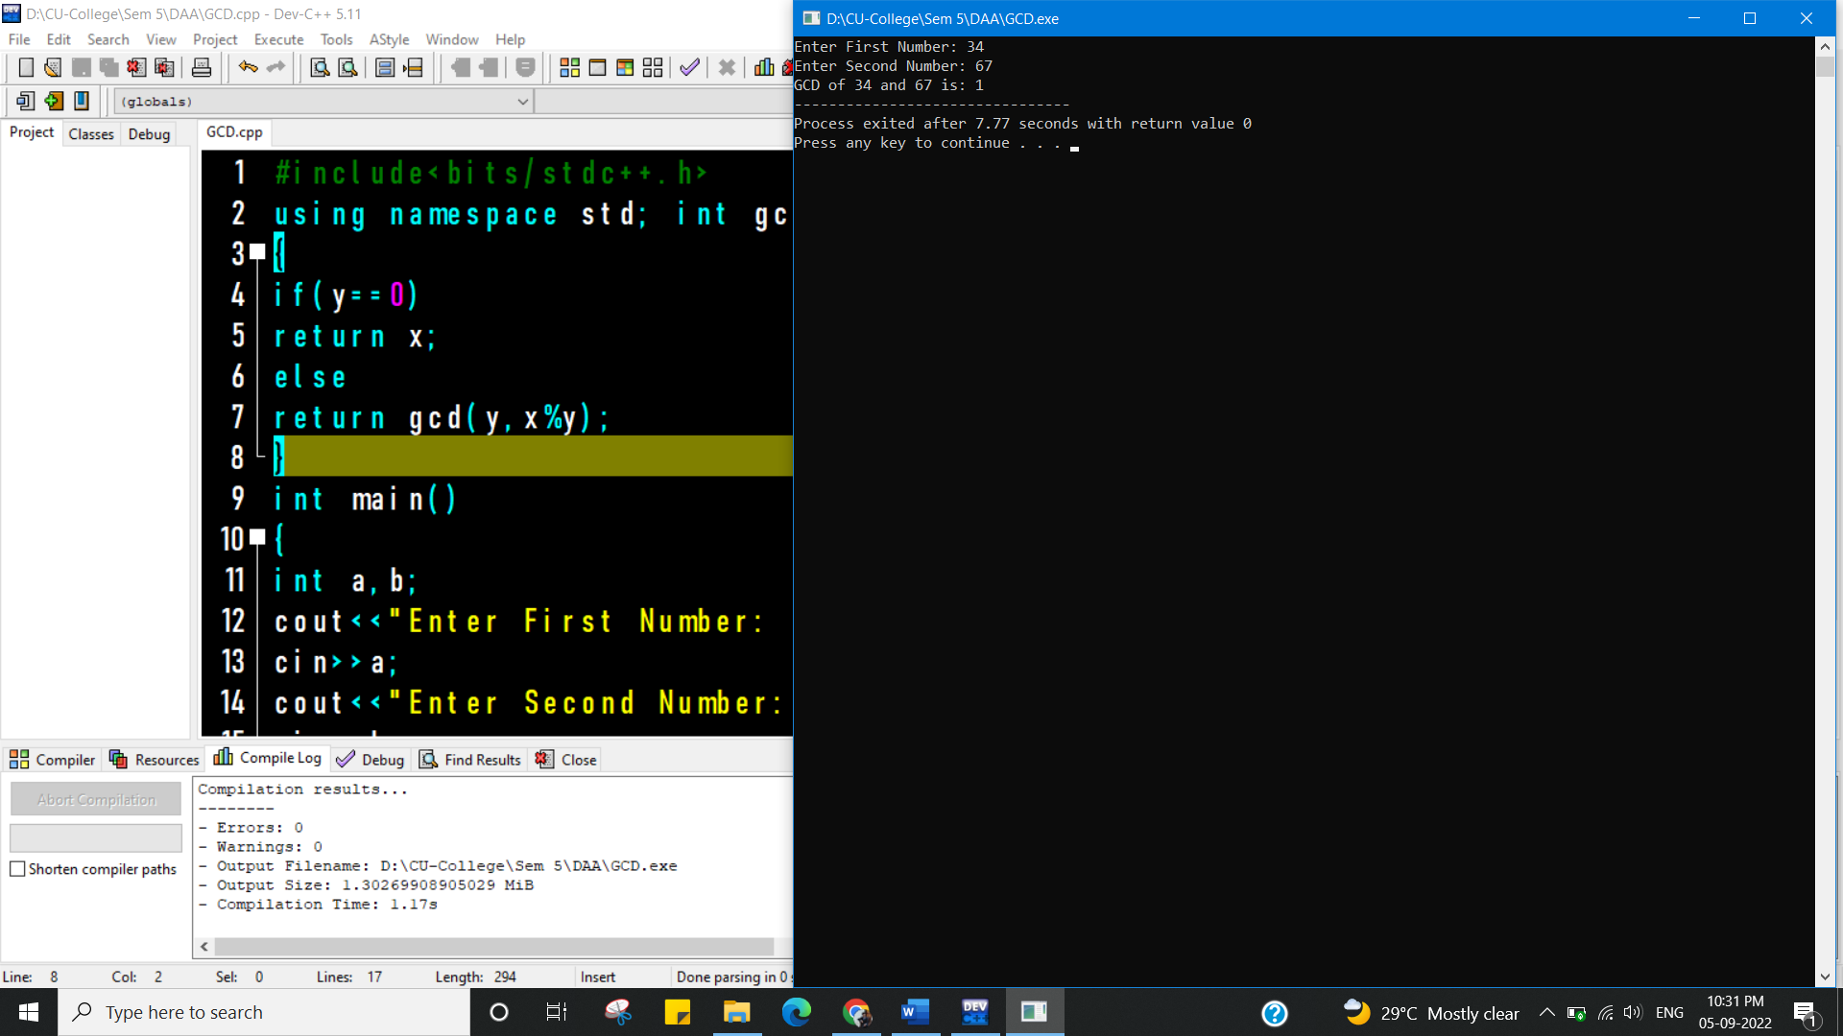

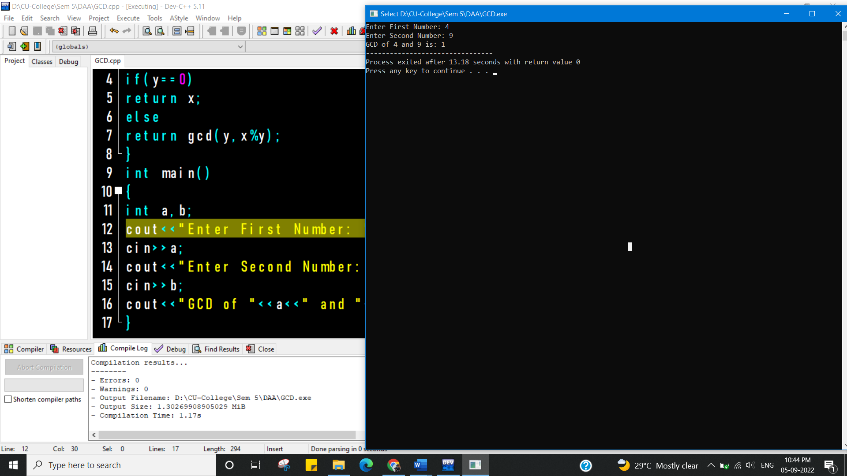

**Learning outcomes (What I have learnt):**

1. To know how Euclidean algorithm works.
2. To learn how to use recursion for solving problems.

**Evaluation Grid (To be created as per the SOP and Assessment guidelines by the faculty):**

|  |  |  |  |
| --- | --- | --- | --- |
| Sr. No. | Parameters | Marks Obtained | Maximum Marks |
| 1. |  |  |  |
| 2. |  |  |  |
| 3. |  |  |  |
|  |  |  |  |